

# Distributed Computing

**Chapter 4.2: Process Management**

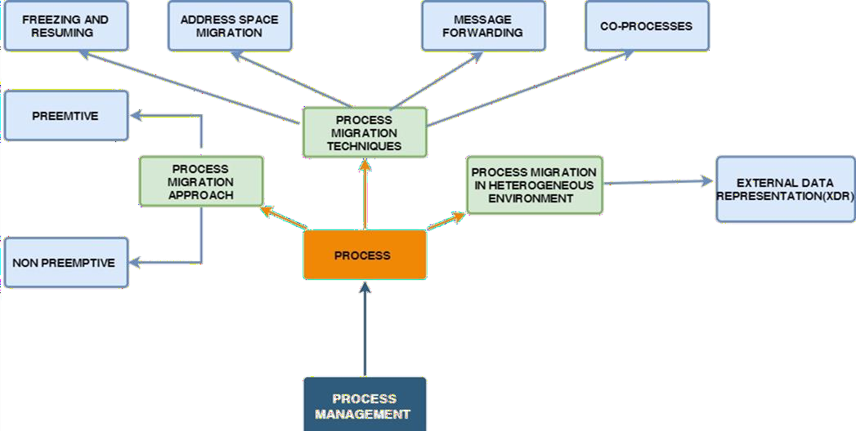

**Time**

**Source node Destination node**

**Execution suspended**

**Migration decision made**

# Process Migration

**Relocation of a process during its**

**Freezing time**

**Transfer of address space**

**execution**

**Execution resumed**



1. **Transparency**
2. **Minimal interference**
3. **Minimal residual dependency**
4. **Efficiency**
5. **Robustness**
6. **Communication between co processes of a job**

**Desirable features of a good process migrating mechanism**

**VIDYALANKAR INSTITUTE OF TECHNOLOGY (LMR OF DISTRIBUTED COMPUTING)**



1. **Freezing at source & starting at destination**
2. **Transferring address space**
3. **Forwarding messages meant for migrated process**
4. **Handling communication between cooperating processes but separated due to migration**

**Process Migration Mechanism**

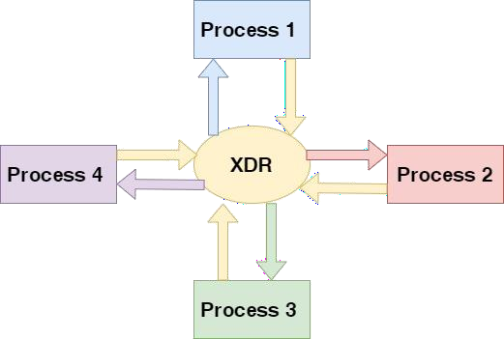

## External Data Representation

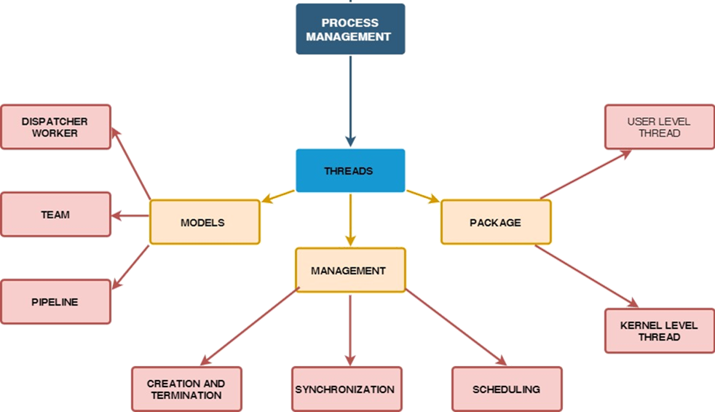

**Thread models**

**Dispatcher Worker model**

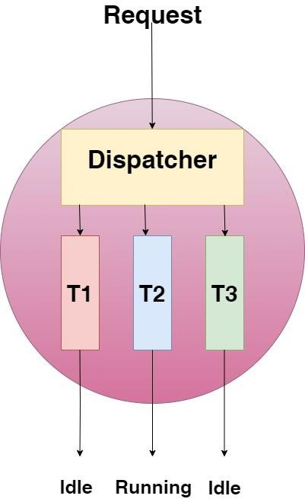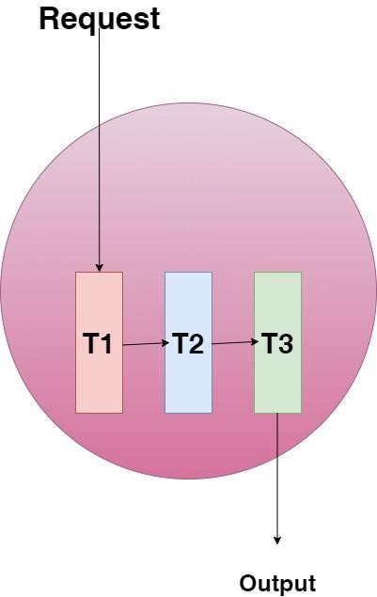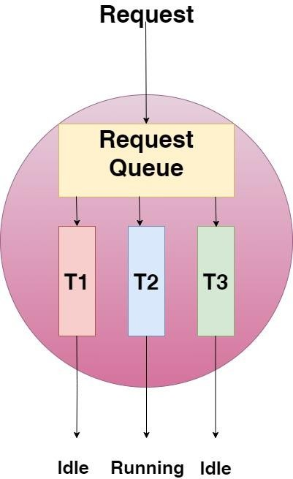

**Team Model Pipeline**

**model**



## THREAD PACKAGE

User

Kernel

Maintains processes status info

Processes & their threads

|  |
| --- |
| Processes & their threads |
| Runtime system Maintains threads status info |
| Kernel  Maintains processes status info |

space

Kernel space



User space

Kernel space

**THANK YOU !!!**

